# **Your Application**

This is the team application form of the Project Abstract Submission phase to the Dell Technologies Graduation Project Competition for Turkey, Middle East and Africa.

Teams participating should consist of 3-6 team members with an assigned team leader to submit the entries and lead the communication throughout the competition timeframe with Dell Technologies. Teams should also have an assigned faculty advisor.

* **Part 1 - Team**
* **Team Leader Name\***
  + **First Nour**
  + **Last Bahaa**
* **Team Leader Email\***
  + **nour1702084@miuegypt.edu.eg**
* **2nd Team Member Name\***
  + **First Abanoub**
  + **Last George**
* **2nd Team Member Email\*** 
  + **Abanoub1703340@miuegypt.edu.eg**
* **3rd Team Member Name\***
  + **First Ibrahim**
  + **Last Fawzy**
* **3rd Team Member Email\***
  + **ibrahim1707047@miuegypt.edu.eg**
* **4th Team Member Name**
  + **First Mai**
  + **Last Mahmoud**
* **4th Team Member Email**
  + **mai1707685@miuegypt.edu.eg**
* **Faculty Advisor Name\***
  + **First Khaled**
  + **Last Hussein**
* **Faculty Advisor Email\***
  + **khaled.hussein@miuegypt.edu.eg**
* **Faculty Advisor University Job Title\***
  + **Professor**
* **How many male team members?\***
  + **2**  
    .
* **How many female team members?\***
  + **2**
* **Your University\***
  + None of the above
* **Your University (in case you didn't find it above)**
  + **Misr International University (MIU)**
* **Country of Residence\***
  + Egypt
* **Part 2 - Project**
* **Project Title\***
  + **Wheat Impurities' Detection**
* **Which sector does your project tackle?\***
  + **Well-Being,**
  + **Healthcare,**
* **Which Technology area are you using to tackle the addressed problem?\***
  + **Internet of Things (IoT),**
  + **Multi-Cloud,**
  + **Artificial Intelligence (AI).**
* **What is the main problem that you are solving?\***
  + **Our project main problem is that: Wild Oats and wheat in the early stages are quite similar in shape and color; moreover, if the farmer didn’t remove it from the land as soon as it appears it will spread its seeds in the ground, which will stay in the land for many years according to the land conditions.**
  + **For the rust, there’re the three different kinds in Egypt. Rust appears due to the change in the weather.**
* **What is the importance of this problem?\***
  + **Wild Oat plant and Wheat Rust disease the crop with its expansion, it reduces the wheat production by 93% for every square-meter. Thus, if the farmer didn't detect the wild oats within the first 30 days of growing within the wheat, it will kill the crop and spread about 100 to 150 of the Oats seeds. Hence, detection in the early stages is a must. Pervasion in wheat fields can diminish yield by as much as 80%. As in Egypt, we plant almost 9 million tons of Wheat; however, we use almost 14 million tons. Due to that we export the rest by 23 billion pounds yearly to fulfill the gap needs.**
* **What are the current solutions?\***
  + **1 - Using expensive Chemicals, which decreases the nutritional value of the wheat.**
  + **2 - Using Winter Planting, will delay the Wheat season.**
  + **3 - Using Lie Agriculture irrigation, will delay the season of the Wheat.**
* **How will your solution solve the problem? What is new?\***
  + **After deep searching regarding this problem we didn’t find anyone worked on it before. This is going to be the first experiment to be made on the Wild Oats.**
  + **We are going to make real-time detection to decrease the appearance and the harm of the Wild Oat and Wheat Rust to increase the Wheat crop production.**
  + **So, We will use data acquisition, image processing and deep learning techniques.**
* **What is the expected impact of your solution from various perspectives (social, commercial, environmental, etc)?\***
  + **It will decrease the number of Wild Oats and rust in the Wheat and increase the crop production. Producing it by the best quality and in larger crop weight output. Above all, it will increase the farmer income and reduce the work and the time he takes in the field to recognize the Wild Oats. Besides, the money he pays for using the expensive high-quality chemicals to control Wild Oats.**
* **Give a high level functional description of your solution. How will it be used?\***
  + **The system proposed in this document is divided into 3 fully connected systems.**
    - **First System: this system is a camera which will be able to classify the Wild Oats & Wheat Rust with it’s different species within the field and also classify where the healthy wheat is.**
    - **Second System: this system is a web application which is connected to our first system to receive the results from the detection. It contains a dashboard to view how many wild oats and wheat rust within the field also, the user will be able to contact the admin using the mailing system.**
    - **Third System: this system is a wind monitoring system to predict if the incoming wind has fungicides that will cause rust in our wheat and sends it’s result to our second system.**
* **Give a high level technical description of your solution: architecture, technology, integration, innovative components, etc.\***
* **Give a high level description of your solution development environment, platform, tools, etc.\***
  + **Anaconda Python Environment**
  + **Camera Module for Raspberry Pi**
  + **Raspberry Pi 3**
  + **Temperature Sensor**
  + **Rain Drop Sensor**
  + **Humidity API**
  + **Wind Speed API**
  + **Arduino UNO**
  + **Google Cloud**
  + **Database**
  + **Laravel version 8**
* **How will you manage your product development cycle, your quality assurance process, your solution deployment logistics, etc?\***
  + **In the development cycle, we are going to collect a real dataset of the wild oat which isn’t found online in cooperation with the Agriculture Research Center and the farmers. After image acquisition, we are going to apply the data preparation methods to clean the data, then construct our model using machine learning and deep learning approaches on the acquired images. After training our model and that it’s fed enough to be evaluated, our application functionality with the help of experts will be ready for taking real-time images of the wheat fields and classifying the wheat impurities' from the healthy wheat.**
  + **After finishing the model and deploying it doesn’t mean that our work is done, we will take user’s feedback of the classification process and try more machine learning/ deep learning methods and redeploy again to get the best results.**
* **Give the most relevant plans that you have developed for your project (for example, time schedule, resource plan, training plan, risk management, contingency plan, etc.)\***
  + 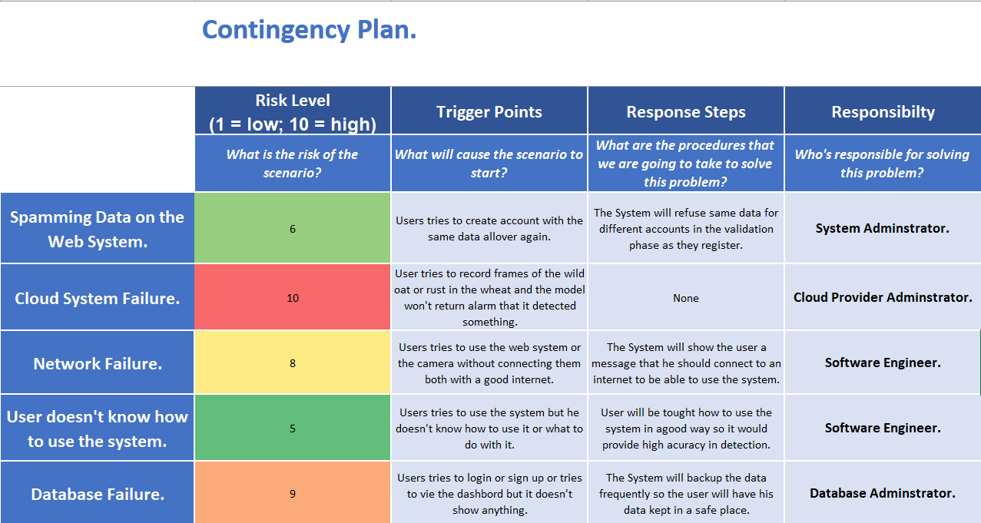**Contingency plan.**
  + **GANTT Chart.**

